Advanced Spreadsheet Assignment

Documentation
Note: This documentation is like a guided tour of the highlights from the workbook that includes the steps done in every sheet and answers the questions set in assignment specification

- Interface:
- Built an Interface using macro on the 1st sheet of the Workbook which helps the user to navigate through the Entire workbook by just clicking on the buttons in “SHEET” Column.

Cleaning Data
- Raw Data:
- Downloaded the Access database file named Assignment.accdb and imported all the data into Excel (Macro enabled workbook)

- Cleaned Data:
- Used Macro Code to delete blank rows and created a button for it. The Button “Delete Blank Rows” shows the Number of deleted blank rows after clicking it.
- Removed double, leading & trailing spaces & cleaned the data using Proper & Trim Function. (In the Highlighted columns)
- Used Macro Code and Expanded all Street data and corrected Abbreviation errors. Created a Button for this using Macro.
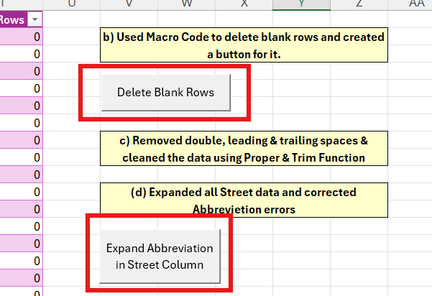

- Corrected all Entries in gender using IF ELSE Formula: =IF(LEFT([@Gender],1)="f","F","M")
- Deleted Duplicate entries Using Excels Inbuilt Function in Data>Data tools>Remove Duplicates.

Organising Data
- VLOOKUP Table:
- Made a VLOOKUP table that contains the list of product codes, product names, case sizes and retail prices.
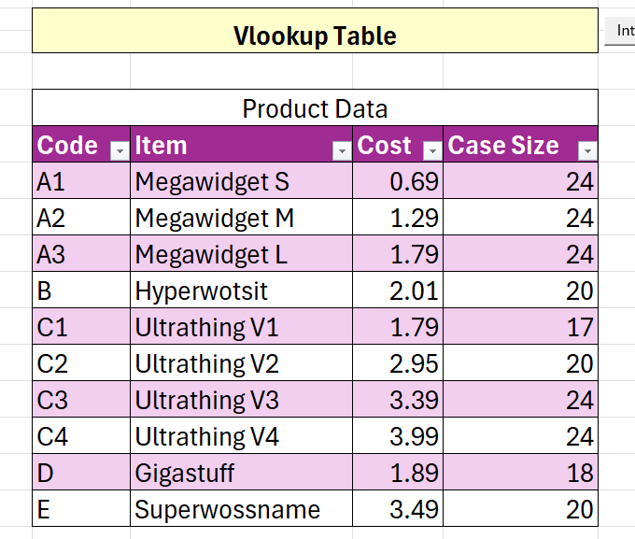
- The table was then used to calculate Quantity Sold and Sales Column in the Next sheet.
Formulas used (In Sales sheet) =VLOOKUP([@Product], Product_Data,4) *[@Quantity]
=VLOOKUP([@Product], Product_Data,3) *[@ [Quantity Sold]]

- Sales:
- Made new columns to calculate Revenue, Cost, Month, Year and used VLOOKUP Formula to calculate It. Column Names & formulas:
Quantity Sold =VLOOKUP([@Product],Product_Data,4)*[@Quantity]
Sales =VLOOKUP([@Product],Product_Data,3)*[@[Quantity Sold]]
Cost =[@Sales]*0.75
Profit =[@Sales]-[@Cost]
Month =TEXT([@[Order Date]],"MMM")
Year =YEAR([@[Order Date]])
Delivery Cost =[@Quantity]*0.5
Discount =IF([@Quantity]>100,0.93,IF([@Quantity]>50,0.95,IF([@Quantity]>20,0.97,1)))
After Discount =@IFS([@Quantity]>100,[@Sales]*0.93,[@Quantity]>50,[@Sales]*0.95,[@Quantity]>20,[@Sales]*0.97,[@Quantity]<=20,[@Sales])
- The data in this sheet is the point of origin for data used in stepwise calculations which was used to create Pivots and Cashflows.

- B, D, E Sales:
- Created Pivot Tables for Product B, D, E Sales & Quantity Sold and Calculated their Growth Percentage from 2021 to 2022
- Inserted a Line graph for the same.

- Sales by Region:
- Made Pivot Table to show Monthly Sales According to Postal Code Area (CW, HS, WC, WS)
- Inserted a Slicer Function for the User to Change the Values in the Pivot Table to check the Values for A1, A2, A3
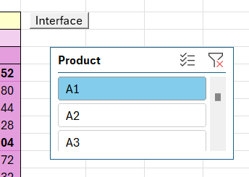
- Inserted a Bar Graph showing the Sum of Sales for the Post Codes with filters of Year & Month.

- Pivots:
- This Sheet contains Pivot Tables for Monthly Sales, Cost of Production, Quantity Sold & Delivery Cost for Product Codes B, D, E for the Year 2020, 2021, 2022
- These Pivot Tables were then used to further Calculate the 2023 Growth % in the Next Sheet.

- 2023 Growth %:
- The Tables in this Sheet show the 2023 Growth % of Sales, Cost of Production, Cost of Quantity & Cost of Delivery in 2023.
- This Data is used to calculate the Cashflow Forecast for 2023 in the next sheet.

The Cash Flow Forecast

- Cashflow Forecast 2023:
- Calculated the Cash Flow Forecast for 2023 that includes all the data given in the coursework brief.
- The User can alter variables (e.g. the length of the business loan & Government Grant etc) In the Cashflow Forecast so that they can see the effects on the business.

Interrogating The Data

- Delivery Cost Cashflow Forecast for 2023 @14.95 Delivery Cost Per Order:
- Made a Pivot table to show Delivery counts for 2021 & 2022.
- To calculate number of deliveries of 2023, we calculated the percentage change in Delivery from 2021 to 2022, and then combined the percentage with the number of deliveries from 2022.
- For example: Number of deliveries in Jan 2021 for Gigastuff (D) is 18 and in Jan 2022, it was 10 Therefore, the percentage change is -44.44%
- To calculate the Number of Deliveries for Jan 2023 for Gigastuff (D), we used the formula =ROUND(C11*(1+C18),0) which gave us 6 as the output
- Used the 2023 estimated delivery numbers to calculate the delivery cost in the Delivery Cost Cashflow Forecast for 2023 @14.95 Delivery Cost Per Order.

- Discount Cashflow Forecast 2023:
- Calculated Discount Cashflow Forecast using Pivot Table and SUMIF Formula to show the affect of Discounted Pricing on company’s Profits.

- 5% Growth Cashflow Forecast for 2023 starting:
- Used December 2022 figures for B, D, E in the Pivot Tables as the Company Plans to increase sales by 5%
- Calculated the 5% growth Cashflow Forecast for 2023 using =GETPIVOTDATA formula

- Monte Carlo Simulation:
- Ran Monte Carlo Simulation using 2 Methods to see how sales fluctuations might affect cash flow.
- Method 1 Using VBA:
- Calculated the Mean & Std Deviation for Sales, Manufacturing Cost, Delivery Cost & Loan Repayment using the Following formulas =AVERAGE(& =STDEVA(
- Created a Button to Run all Simulation that gives the Average Values for Sales, Manufacturing Cost, Delivery Cost & Loan Repayment & Probability of Sales more than 2023
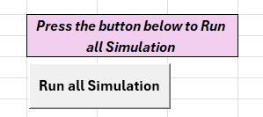
- Method 2: Running 1000 Manual Simulations
- Ran 1000 Manual Simulations Using the Formula =NORMINV(RAND ()

- TEST PLAN:
- Carried out 10 basic testing of the application.
- All the Tests except test 9 were Passed and showed Expected Results.
- We corrected the errors in Test 9 by inserting slicers so that the user can check the data for a particular Month/Year. Included the Screenshot for this as well.
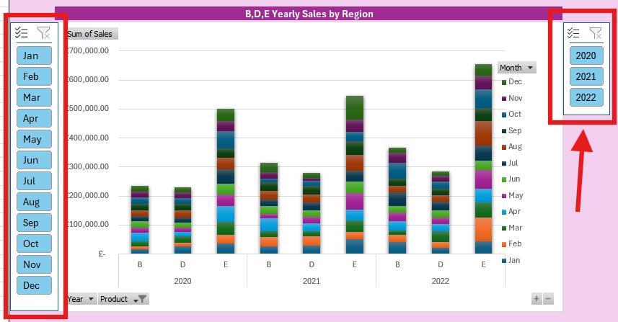

- DASHBOARD:
- Created an Interactive Dashboard that shows a summary Charts & Graphs from the Workbook.
- Used Pivot Data to create all the graphs.
- The Following Graphs & Charts are displayed on the Dashboard:
- B, D, E Yearly Sales by Region
- Yearly Sales by Postcode Area CW, HS, WC, WS
- Cashflow Forecast 2023
- Delivery Cost @14.95 Delivery Cost per order
- Discount Cashflow Forecast 2023
- 5% Growth Cashflow Forecast for 2023
- The User can alter the Variables in “Alterable Variables” Table and see the effects on the following Graphs.
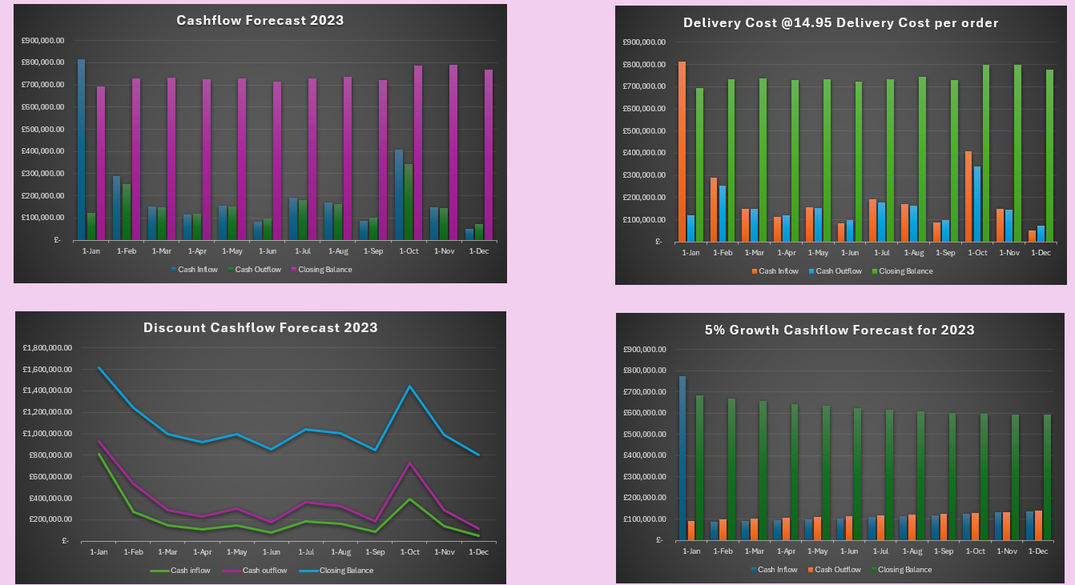
- Created a button using VBA code for the user to Reset the Values to Default.

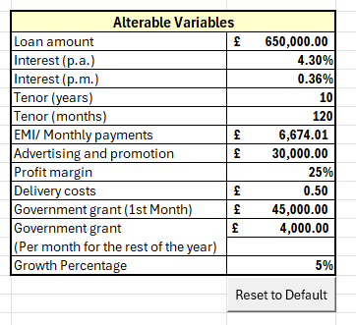

Appendices

VBA CODES

Delete Blank Rows:

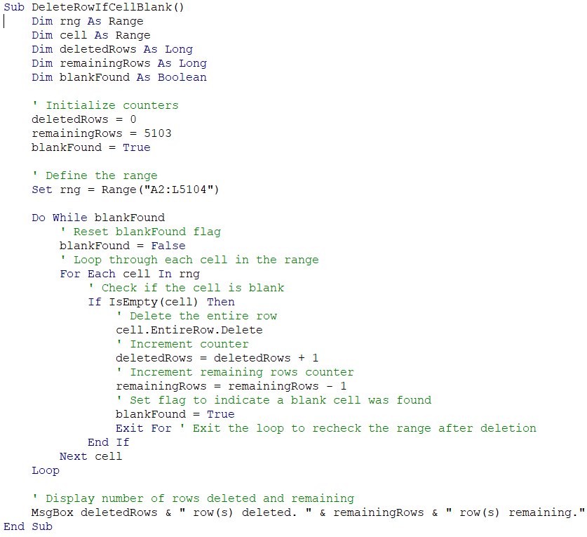

Abbreviations Expanding:

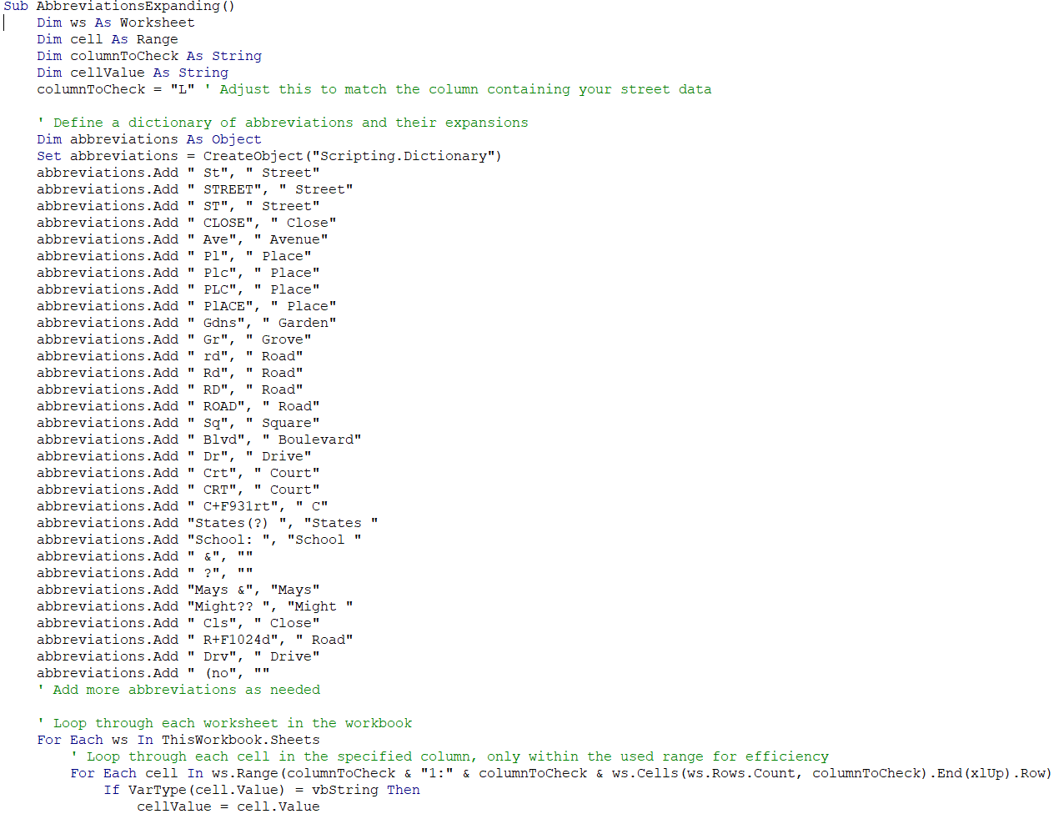
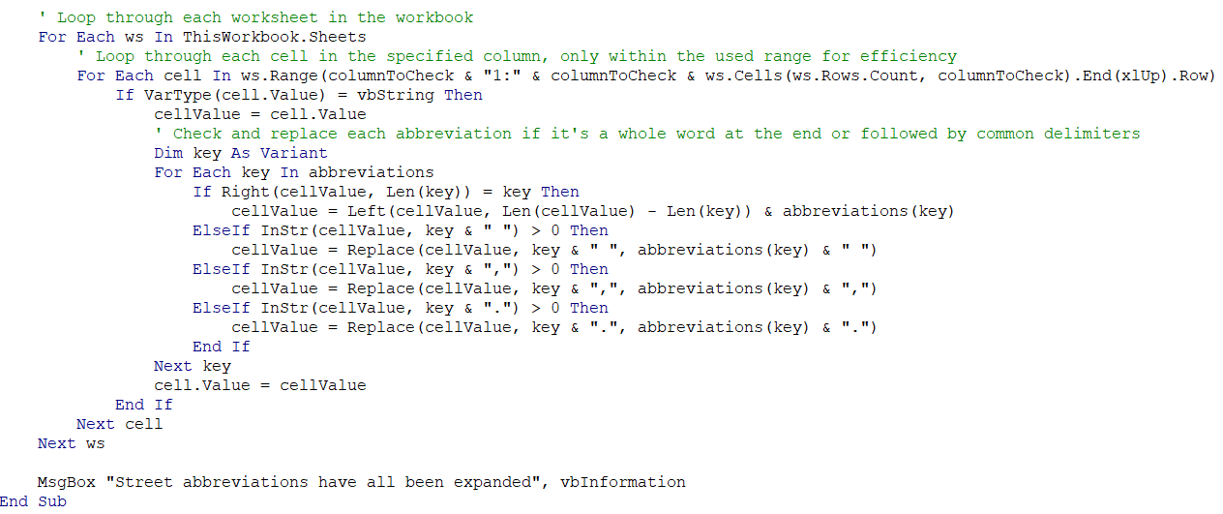

Run All Simulation:
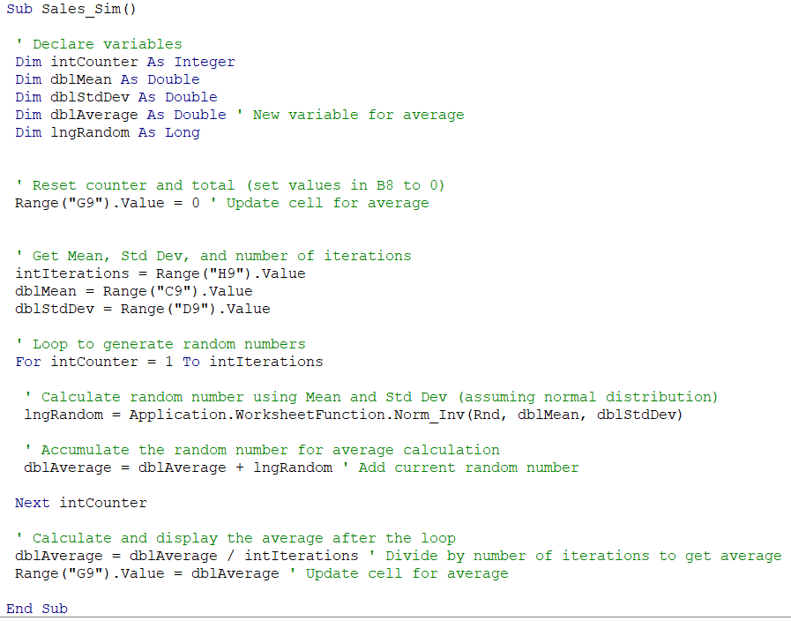

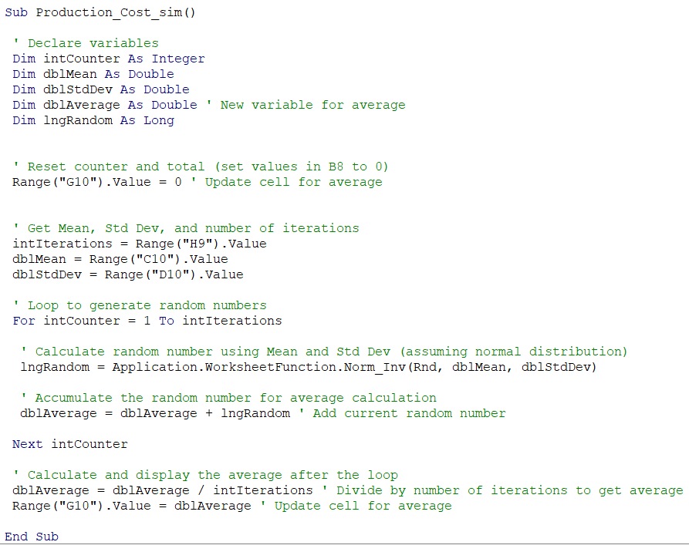
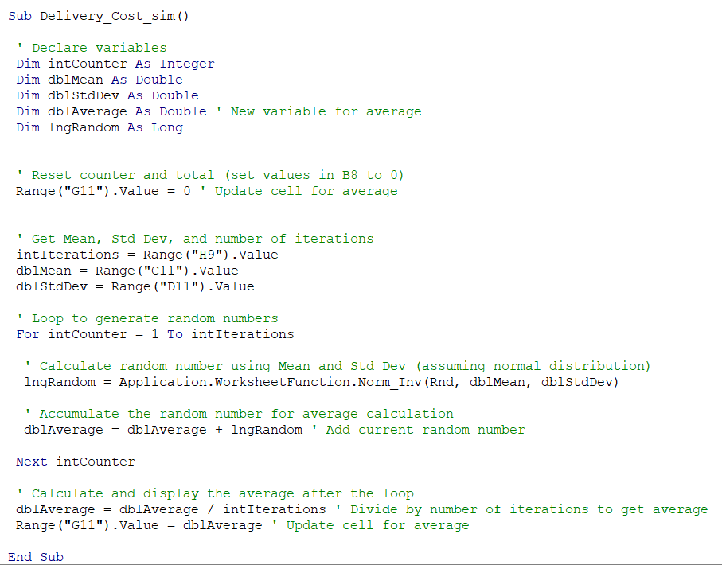

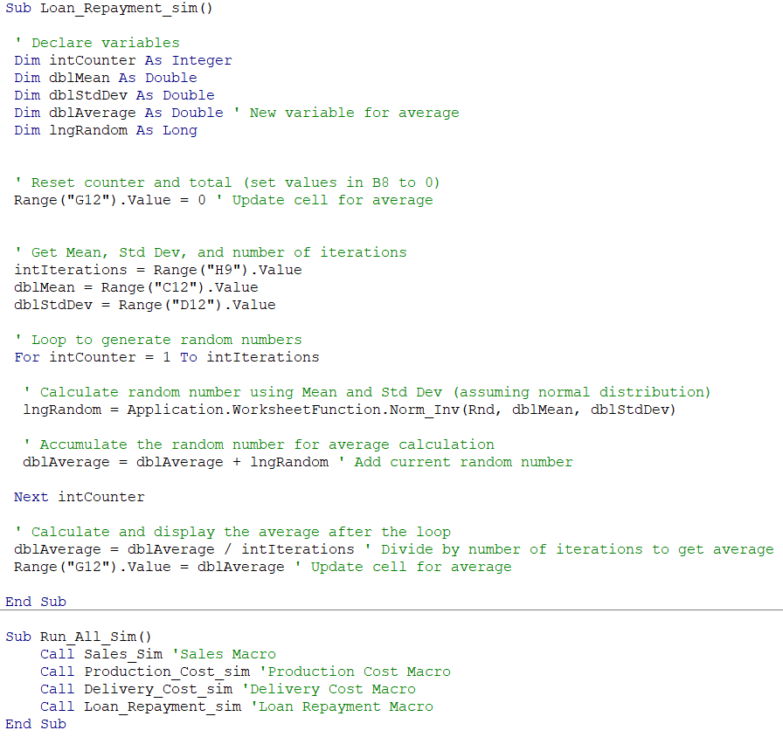

Reset Values to Default in Dashboard:

